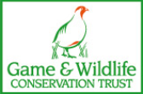 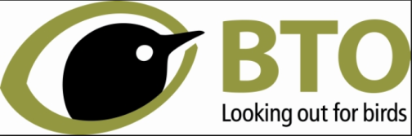 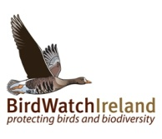 

  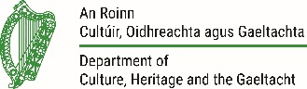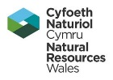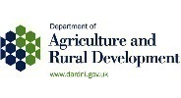

**UK and Ireland Curlew Action Group**

**Recommendations for Curlew**

**Background**

Curlew are found throughout the year in the UK and Ireland, frequenting coastal and some farmland areas in winter, and breeding on upland grassland and moorland and in some lowland wet grasslands and heathlands. Formerly widespread across the UK and Ireland, the Curlew is now undergoing a sustained decline and is now in serious trouble in parts of its range.

The UK and Ireland holds up to 27% of the global breeding population. The Eurasian Curlew is listed as globally Near-Threatened on the IUCN Red List of Threatened Species and is a Red-listed Bird of Conservation Concern in the UK.

The annual Breeding Bird Survey has revealed that between 1994 and 2016, Curlews have declined by 31% (England), 59% (Scotland) and 68% (Wales). In Northern Ireland, the population has decreased by 82% since 1987. More recent work in the Republic of Ireland estimated that the breeding population may be less than 150 breeding pairs, down from 3,750-4,000 pairs in the late 1980s - a decline of 96%.

In Southern England, recent surveys have shown there to be fewer than 300 pairs remaining. Consequently, populations in Ireland and Southern England are thought to be at risk of imminent extinction.

The main reason for the decline is that too few pairs are producing young to maintain numbers. The key factors for this are likely to include: habitat loss and fragmentation, for example through agricultural intensification, drainage of grasslands and changes in grazing; high levels of nest and chick predation; nest destruction due to a switch from traditional hay management to silage; human disturbance; afforestation; and land abandonment.

The combination of global conservation status, rapid decline and the global importance of the UK breeding population makes Curlew arguably the most urgent bird conservation priority in the UK.

**What are we doing about it?**

The UK and Ireland Curlew Action Group brings together the five statutory agencies, JNCC, the RSPB, Birdwatch Ireland, the British Trust for Ornithology, the Game and Wildlife Conservation Trust and the Southern Curlew Forum. The aim of the group is to shape, drive and co-ordinate research and conservation action across the UK and Ireland with the aim of improving the conservation status of Curlew, and to support international obligations, for example the African-Eurasian Waterbird Agreement, to that end.

Although there is work underway there is still much more to be done if we are to have any impact on stabilising the breeding population of Curlew. It requires farmers, land-managers, conservation organisations and government agencies to work together both locally and nationally.

**Recommendations for Curlew in the UK**

**Generally**

Currently business as usual is not delivering for Curlew. Urgent action is required to raise awareness of the plight of Curlew and to develop the support package necessary (public, political and funding) to improve the status of the species across the UK and Ireland. This includes ensuring:

* Agri-environment funding continues and prescriptions are improved post Brexit to support farmers to manage land to benefit Curlew.
* Sufficient resource is available to advise, encourage and assist farmers to access, deliver and to monitor agri-environment schemes for the benefit of Curlew.
* Special Protection Areas are designated for non-breeding Curlew across the four countries. However, currently there are no SPAs with breeding Curlew listed as a qualifying feature. It is critical that key breeding sites are identified and classified, and that their protection and management is sustained post-Brexit.
* Support is provided to reduce the losses of eggs and chicks to main predators across the wider landscape such that breeding productivity is sufficient to increase and maintain populations.
* While dealing with the immediate problem of high predator numbers, research is needed in the longer-term to develop an understanding of why predation rates are unsustainably high in Curlew landscapes and how we can reduce them.
* Consideration of head-starting[1] and related conservation breeding measures to support populations that are in danger of imminent extinction, or which are beginning to show recovery from a dangerously low number.
* Support for *clusters* of farms/nature reserves managing for Curlews, so that a suitable scale of Curlew-friendly landscapes can be achieved.
* Additional funding is available to relevant agencies and conservation organisations to respond to the causes of decline and investigate and deliver the optimum, sustainable land management practices to benefit Curlew across landscapes at scale.

**Uplands (including meadows, pastures and marginal areas)**

* Future sites for forest expansion and renewable energy should avoid key sites. All four countries have ambitious forest expansion and renewable energy targets to meet climate change commitments. The development of opportunity and sensitivity maps for these sectors could help in avoiding key areas for breeding Curlew.
* Farmers are encouraged and supported to adopt extensive grazing practices to help maintain the habitat mosaic and vegetation structure favoured by curlew. Also, to dispose of fallen livestock.

**Lowlands**

* Key habitats such as lowland bogs, heaths and wet meadows are retained.
* Farmers are encouraged to restore natural field drainage, to use electric fences around nests and to delay hay cutting until after the Curlew breeding season.
* Support is available for other innovative measures that can increase chick production.
* Appropriate measures are in place to manage inadvertent human recreational disturbance of nesting Curlews, while taking opportunities to build support for Curlew conservation among local communities (such as creating ‘Curlew guardians’).

1. The standard conservation management technique which involves removal of new-laid eggs from nests, their artificial incubation, and then their return to nests just prior to hatching. This reduces predation risk during incubation.