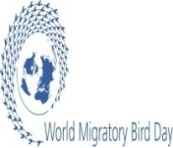

SUMMARY REPORT OF 2017 WORLD MIGRATRORY BIRD DAY CELEBRATION IN ETHIOPIA.
BY: MIHRET EWNETU MULUALEM
In Ethiopia the 2017 World Migratory Bird Day was colorfully celebrated on the third week of May 20 and 21 at Lakes Chitu, Shalla and Zeway in the Central Rift Valley. Education programmes, lectures, bird walks and media coverage were the events covered on the occasion.
With the theme “Their Future is our Future-A healthy planet for migratory birds and people”, the day has made an explanation on the topic of “Sustainable Development for Wildlife and People.” This year’s theme which is linked with UN Sustainable Development goals has created great opportunity to acquaint the participants of the celebration with the two goals that deal with the conservation of natural resources that are crucial for the future of humankind. Of the 17 goals of the United Nations adopted in September 2015 the two goals stated as Life below Water and Life on Land are exclusively dealing with the immediate need of conserving biodiversity both in water and on land upon which people are dependent on these resources.
Currently changes in the quality and size of the wetlands due to unplanned development activities have complicated the issue of bird conservation in many parts of the world. In Ethiopia the situation is worsening as these development undertakings are carried out in the Rift Valley area which is the most fragile ecosystem but did not get proper attention of integrated and sustainable approach of development. The wetlands in the Rift Valley lakes of Ethiopia are the major feeding and stop over sites where hundreds of thousands of migratory birds congregate at the peak seasons from November- February. Many of the lakes in this particular region are also designated as Important Bird Areas which need high priority for bird conservation and bird relate- tourism activities. That is why every year Ethiopia is celebrating World Migratory Bird Day in the Central Rift Valley to raise awareness of the need for sustainable management of the natural resource with main attention focused on bird conservation.

The main topics raised during the celebration were:
- Why bird migration and the need for conserving Migratory Birds?
- Situation Analysis of the three Lakes of Chitu, Shalla and Zeway and the need for Policy makers to intervene urgently to resolve the threats overhanging on these lakes.
- Conservation efforts carried out in the area for the betterment of the resource status.
- The status of the co-ordination of different stakeholders working in the area.
- The water bird resource potentials of the lakes Chitu and Shalla found in Abijata-Shalla Lakes National Park.
People from governmental and non-governmental conservation institutions, local community elders, school teachers and journalists have been invited and attended the celebration. All the events were organized jointly by Ethiopian Wildlife Conservation Authority which is the focal institution for CMS and AEWA and the Ethiopian Wildlife and Natural History Society which is the Birdlife partner in Ethiopia.
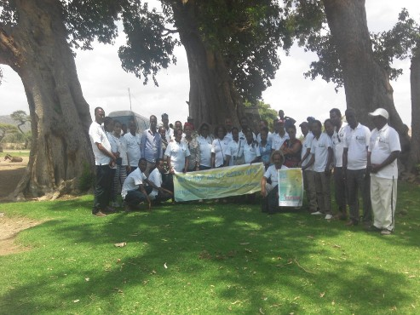
Fig. 1: Conservation Community in Ethiopia Celebrating WMBD

